**Overview**

These steps install and enable a Custom Vision Service demo analyzing images depicting the severity of damage to cars that you can use for a variety of situations. The demo shows how powerful the Custom Vision Service is in enabling the creation of brand-new machine learning models using images and descriptions of those images.

**Step 0: Azure Subscription Requirements**

**You must have an Azure subscription and the ability to create new resource groups for this demo to work.** It is beyond the scope of this document to get into these details, but even a [free Azure account](https://azure.microsoft.com/en-us/free/) should be able to install and use this demo.

**Step 1: Creating Custom Vision Resources in Azure**

To install the demo, you must first generate API keys for the Custom Vision service. Follow these steps to generate the API keys:

Click on “Create a resource”, type “Custom Vision” in the resulting textbox, and select Custom Vision from the dropdown underneath the textbox.

Next, confirm your selection by clicking on the “Create” button

**Step 2: Configure the New Service**

Next, set up the high-level configuration for your new service:

* Give your service a name, for example CarDamageDemo
* Specify the subscription that you will use for the new service
* Specify a location to deploy the service – **IMPORTANT: you must select South Central US as this value is hard-coded in the demo installation.**
* Specify prediction/training pricing tiers: select S0 for both – you will not be using this demo enough to generate financial charges
* Specify a resource group for this new service: resource groups are logical containers and we recommend clicking on the “Create new” link and using a newly created resource group (in the image below named CognitiveServicesDemos)
* Click on the blue “Create” button

**Create**

**Step 3: Retrieve the API Key**

Once your Custom Vision service is created, we need to find it so we can retrieve the API keys. Search for the name of your service (we recommended CarDamageDemo earlier). You should find two services (one for training with the name you gave your model and one for predictions with “_Prediction” appended to the name you gave your model. Click on the training model with the name you specified.

Click on “Keys” under Resource Management

Find the value in Key 1 and copy it to your clipboard. You will paste this value when the demo installation program asks you for the training key.

**Step 4: Run the demo installer**

Open the AzureCustomVisionDemoInstaller.csproj project in Visual Studio. It should load Program.cs as part of the project. Press F5 to run the project, taking care to fix any missing references. The first thing the demo installer will ask you for is the API training key you just retrieved. Paste the training API key you copied from the Azure portal into the prompt and hit the <Enter> key.

The demo installer will prompt you for a zip file – specify the full path to the Car Damage Assessment.zip file that is part of this package. The zip file contains images that were in several different folders before being zipped. The Custom Vision model will take its name from the name of the zip file and the folder names within the zip file will become tag names and the images in each zipped folder will become associated with the tags of the same name.

Once the model is installed and trained, it will ask you for the prediction key. While you could have retrieved this from the Azure portal when you retrieved the training key, we will instead log into the customvision.ai portal to retrieve that key.

**Step 5: Log in to the Custom Vision site**

Go to the Custom Vision website at <https://www.customvision.ai> and click on the blue sign in button.

You should see a new project (model) named Car Damage Assessment within the resource group that you specified when you created the Custom Vision resource in the Azure portal.

**Step 6: Evaluate the accuracy of the new model using new data**

Click on the Car Damage Assessment model to see what the installation routine created:

* Ten images tagged as a dent and ten images tagged as a total loss (you can see which images are associated with each tag)
* These twenty tagged images form a new machine learning model that has been trained to distinguish between minor car crashes (dents) and major crashes resulting in total losses.
* To test this model using a new image that the model has not previously seen, click on the “Quick Test” button and select the Car2.jpg file from this package.

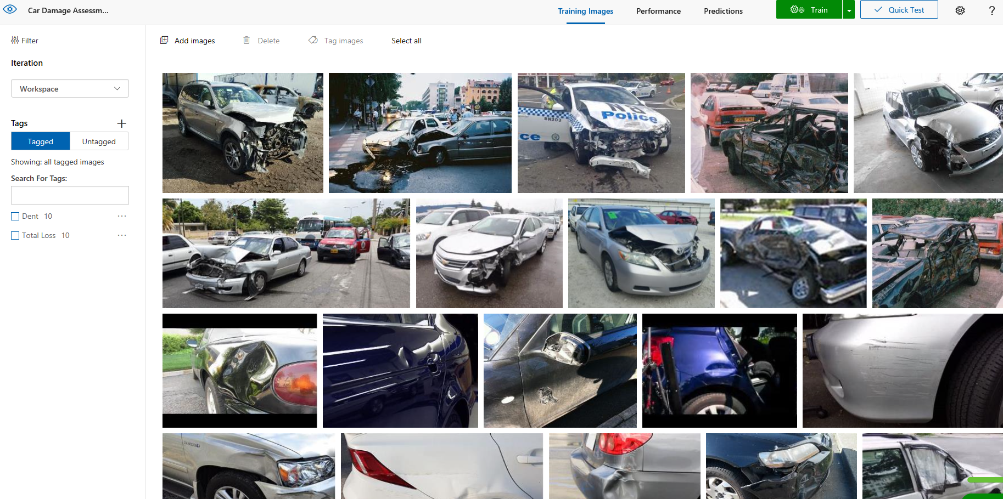

When the Car Damage Assessment model evaluates the Car2.jpg file, it classifies the image as a dent with a certainty of over 99 percent. Next, click on the performance link.



In the performance area, click on Prediction URL:

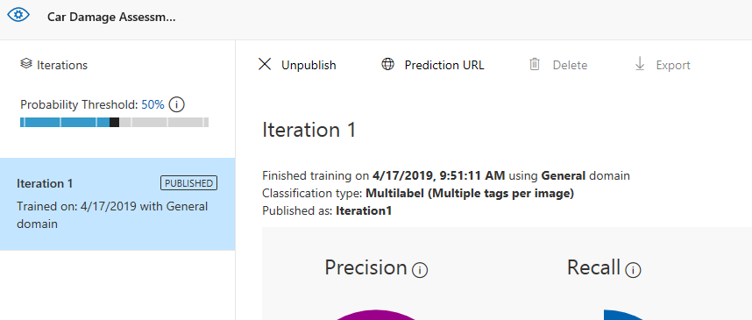

You will see a popup dialogue box entitled “How to use the Prediction API” with information for an image URL and information for an image file. Since you have Car2.jpg on your local drive from downloading this package, you will ignore the upper part of the dialogue box.

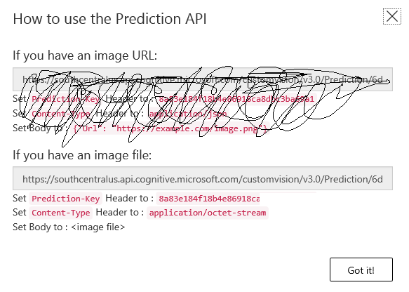

From this dialogue box, copy the prediction key from this window and return to the demo installer to paste the prediction key into the installer program’s prompt for the same. In the case of the above screenshot, the prediction key starts with “8a83” although yours will be different.

You will also supply to the installer the full path to the image that you want to test (Car2.jpg) and the endpoint URL. In the case of the above screenshot, the endpoint URL starts with “https://southcentralus.api” and you will want to take care to copy the entire string even if the end is not initially visible.

If everything has been done properly, you will see JSON data containing information about the prediction returned from the Custom Vision model you just installed.